**Create a canvas app with unique controls**

1. Sign-in to [Power Apps](https://make.powerapps.com/).
2. On the Home screen select **Canvas app from blank**

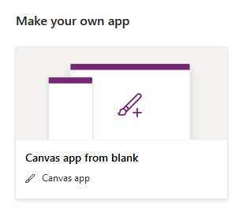

1. Name your app **New UI App** and click **Create**.

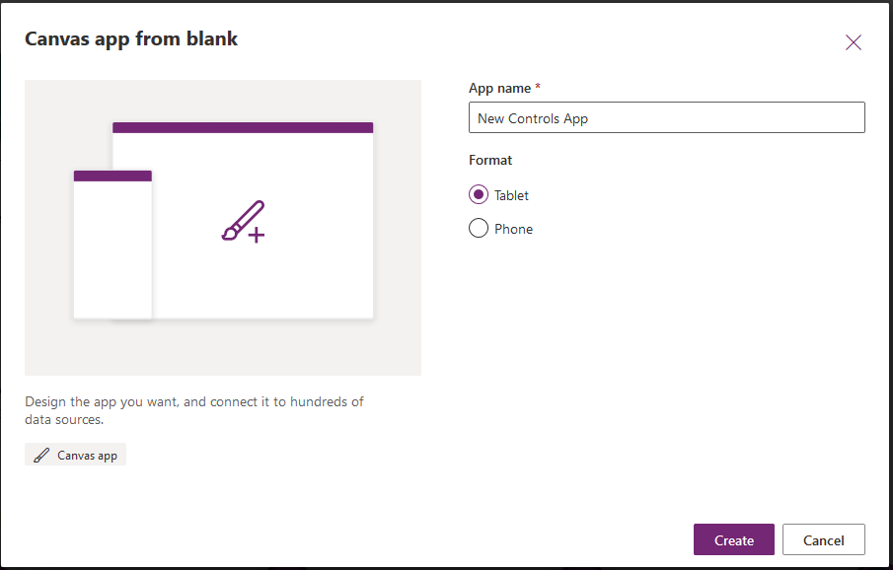

1. Select the **Insert** tab and add a button, and set its **OnSelect** property to this formula:

PowerApps Formula

ClearCollect(CityPopulations, {City:"London", Country:"United

Kingdom", Population:8615000}, {City:"Berlin",

Country:"Germany", Population:3562000}, {City:"Madrid",

Country:"Spain", Population:3165000}, {City:"Rome",

Country:"Italy", Population:2874000}, {City:"Paris",

Country:"France", Population:2273000}, {City:"Hamburg",

Country:"Germany", Population:1760000}, {City:"Barcelona",

Country:"Spain", Population:1602000}, {City:"Munich",

Country:"Germany", Population:1494000}, {City:"Milan",

Country:"Italy", Population:1344000})

1. Press and hold **Alt Key**, and select the **Button** control. (This will create your collection and store all the information.).
2. Select the **Gallery** dropdown at the top and choose **Blank vertical** gallery and choose **CityPopulations** from the data source pop up.
3. With the gallery selected, in the right pane, change the layout from blank to **Title, subtitle, and body**.
4. Select the last or third Label in the first item of the gallery, and change the **Text** property to **ThisItem.Population**.

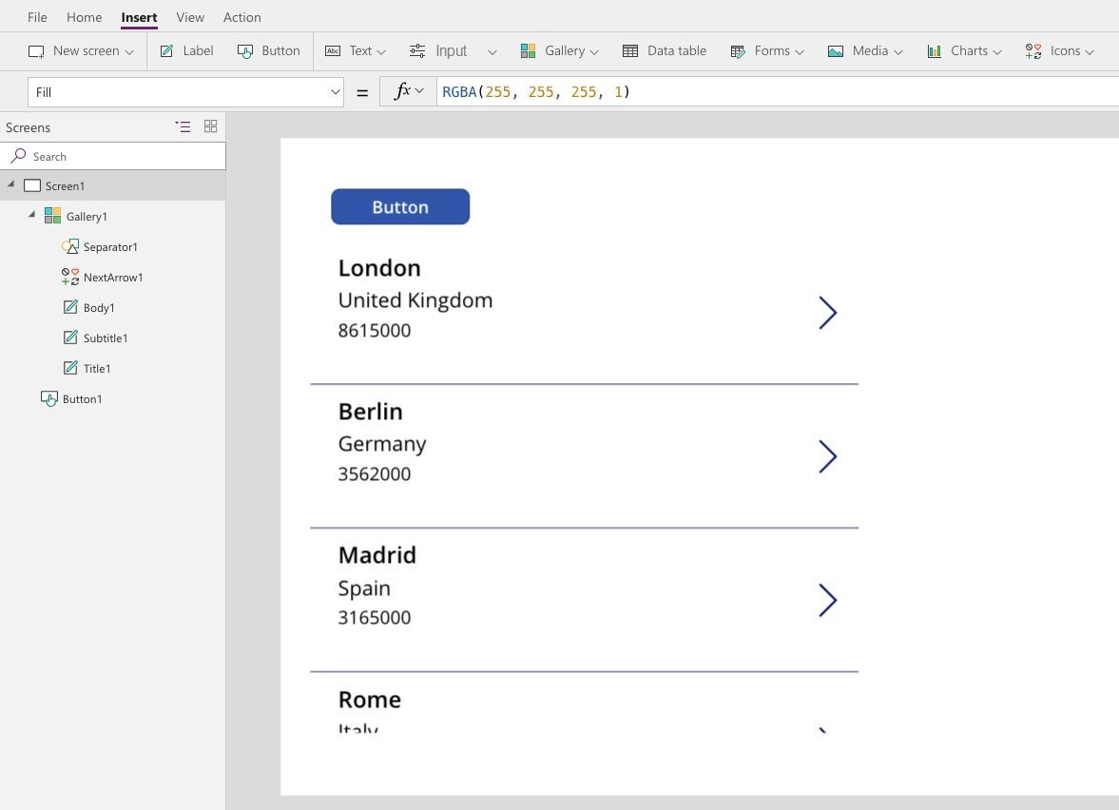

1. Select the **Input** dropdown and choose **Slider**.
2. Change the **Maximum** property of the slider to 10000000.
3. Insert a **Label** and change the **Text** property to **Slider1.Value**.
4. Select the first item in the gallery, and click **Icons** from the top bar and choose the **Check**.

**Note**

You should see multiple check marks appear in each cell of the gallery. This is as intended since a gallery repeats the format for all items the same as the first item. If you don't see multiple check marks, make sure you have selected the first item in the gallery and insert a **Check** icon again.

1. Change the **Visible** property of the check icon to:

PowerApps Formula

If(ThisItem.Population > Slider1.Value, true, false)

